## Alarm handling

Alarm handling is determined in a set of international rules by standardization organisations. These rules are visualized in Figure 2‑1.

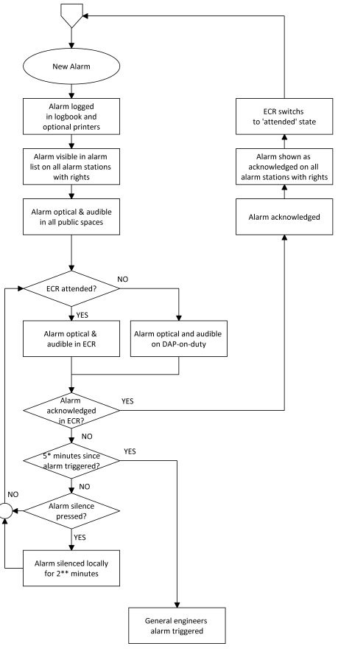

Figure 2‑1: typical alarm sequence